Patanjali's scientific yoga of Shri S.N.Tavaria.
Following article is from Shri S.N.Tavariaji’s Teaching.

SEVEN MINUTES TO HEALTH HARMONY & HAPPINESS

TOTAL HEALTH THROUGH RHYTHMIC BREATHING

Maharshi Patanjali's Scientific Yoga descends through Guru- disciple tradition orally since last 5000 years. It was for the first time put in black & white by late Shri S. N. Tavaria (2-3-1918 to 29-5-1994), realizing ardent need to uplift the human species from being anarchical to realize its full potential i.e. ULTIMATE TRUTH.

He had been practicing this yoga since early childhood under guidance of his transcendental master and achieved PARAM SATYA –The ultimate truth.

He had written 1) Education for Attention (2) Yoga Sutra of Sage Patanjali EXPOSITION & PRACTICES (3) The Purpose of Birth & Death.

His work is divided in 9 Parts

1) Corrective exercise 2) Refining Exercise 3) Gold Nugget 4) Positive Tension 5) 3 Steps Rhythmic Breathing (3SRB) 6) Upgrading of Awareness 7) Phase Exercise 8) Swara Yoga 9) Intensity Charts

We shall deal here with the program of SEVEN MINUTES FOR SELF which will include part 2, 3, 4 and 5.

- REFINING EXERCISES

To remove emotional blocks, tone up nerves, improve blood circulation, ease tension & joint pain, to improve working of thyroid gland, to clear chocked emotion, to activate THALAMUS (Sahastrar Chakra). This is a set of six exercises which will cleanse residue of undigested experiences and any kind of accumulated Toxins gross or subtle

TECHNIQUE AND RHYTHM:
1) Exercise No. 1: Stand erect or sit comfortably with both palms on chest. Take deep fast inhalation and exhalation (36 Breaths per minute - in 3SRB pattern for 60 seconds)
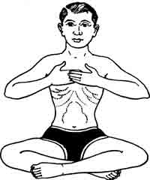

2) Exercise No. 2: Same as above but keeping palms on naval and using lower lungs. (36 Breaths per minute- in 3 SRB pattern for 60 seconds)
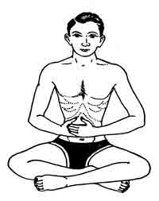
3) Exercise No. 3: Sit with both legs stretched holding toes, chin slightly up and breathing pattern same as (1) but using both the lungs. (36 Breaths per minute- in 3 SRB pattern for 60 seconds)
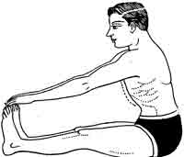

4) Exercise No. 4: Take five short quick inhalation to fill full lungs and followed by one forcefully exhalation by mouth - 5 times
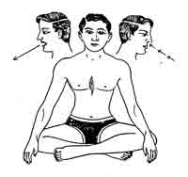

5) Exercise No. 5: Inhale through nose 5 seconds, retain (hold) breath for 5 seconds, exhale for 5 seconds, keep empty (external retention) for 5 seconds. This is one- round. Repeat such 3 to 5 rounds .
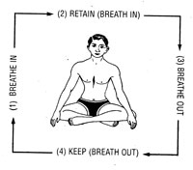

6) Exercise No. 6 : Take in deep full breath close both nostrils with your fingers, let chin press on chest and swallow saliva as if drinking water - 3 times, raise head and release breath. This is one round. Repeat such three, rounds.
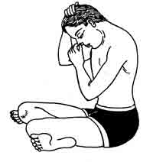

- GOLD NUGGET

Method: Sit comfortable, back erect, empty lungs completely keeping one hand above naval and one hand bellow the naval, pull in lower abdomen below naval as much as possible ( it will pull perineum 'area between muladhar and swadhistan chakra) hold the abdomen tightly starting with 10seconds -and gradually increasing 5 sec. per week maximum up to 40 sec. Now release and inhale. Repeat such three rounds. Latter when you reach 40 sec. Keep holding lower abdomen
Tightly and take shallow breaths in the top part of the chest for 1 minute to start with later gradually increase up to 2 minutes and 20 seconds. Do this only once.

This activates Perineum-Diaphragm muscles and Bindu Chakra in skull and thus dormant centers in brain are activated and you can communicate with higher centers (mind of god) like insight centers, intuition center and silent area. You can develop intuition and creative ability.

This is most potent and powerful exercise do it under proper guidance for full benefit, you will see positive transformation in yourself. in a short period of time.

- POSITIVE TENSION

These are few simple stretching and relaxing exercises of (1) Fist and hand up to shoulder (2) Left and Right Leg (3) Chest (4) Abdomen (5) stand on toes and stretch your arms above head stretching full Body - To be done 3 times each gradually as demonstrated. This will help deep relaxation and at night sound sleep.

- SWAISO: Swinging of arms up and down in 36 per minute rhythm can be included.

  - 3 STEP RHYTHMIC BREATHING (3SRB)
This is most important part of SHRI TAVARIAJI’S teaching. This is an invaluable, priceless practice.
ALL PURPOSE YOGIC WAY OF BREATHING, to be adopted step by step for 24 hours replacing our present unconscious faulty shallow breathing.

It consists of 12 cycles of full breath (i.e. inhalation and exhalation) per minute, each cycle comprising of: 3 heart beats for inhalation + 1 heart beat of transition period from inhalation to exhalation + 2 heart beats of exhalation (considering 72 heart beat per minute. I.e. inhale for 3 seconds & exhale for 2 seconds using full lungs). This is natural rhythm of child since birth up to 27 months, it is the rhythms of sea also( Nature)
It's salient features are:
- Change of shallow and partial breathing into deep and full breathing
- Passing of precise (time measured) rhythm from blood cells-to -tissues-to organs-to-entire brain - body system
- It automatically slows down the tempo of memory - associated thoughts and impulses impinging non-stop on conscious mind. in turn reacts ruling out focusing of attention. This is slow because thinking and breathing are closely related
4) The rhythmic flow of blood carries energy (Prana) to every part of the body. The rhythm replaces conflict, with harmony -- and imbalance with balance. It cumulatively improves health and elevates mind immensely and makes our body brain system a fit medium for self-illumination
5) It enables to have what is termed" A MEDITATIVE ATTITUDE" throughout 24 hours a day endowing man with equipoise, keeping him calm and unruffled in facing challenges, pleasant and unpleasant situations in practical and spiritual life

1) Technique: Initially lie down flat on your back keeping two relatively heavy books on your chest and naval and practice inhalation and exhalation such that both lobes of the chest move simultaneously up and down. Practice for five minutes. After enough practice remove books and keep hands on chest and naval
2) Volume: Now Inhale and Exhale normal volume of air as you do in normal breathing and now practice it sitting, and walking also.
3) Rhythm: Now you can easily inject rhythm in above breathing i.e. inhale for three sec. and exhale for 2 sec. This practice can be done any time of the day replacing present shallow and faulty breathing at a stretch you can do for 30 minute (for timing rhythm a musical tape is available which you can use at the night before sleeping so that the rhythm becomes a unconscious habit all throughout the day i.e. 24 hrs.) These are the three steps of 3 Step Rhythmic Breathing
http://3srb.org
under section- “download “ free download of his books and 3srb and refining music.
Friends these simple exercise are time tested and bound to transform your personality in six to twelve months without fail. One can start from seven years age onward.

Total health harmony and happiness is granted provided you do not miss your exercises a single day, as our master was always teaching us 7 - 1 = 0 , 30 -1 = 0 , 365 - 1 = 0 .

Inhale Love & Exhale Forgiveness

